# User manual Tweader

## start the stream

To start tracking tweets you just have to fill in a **search word or hashtag** press the **start** button:

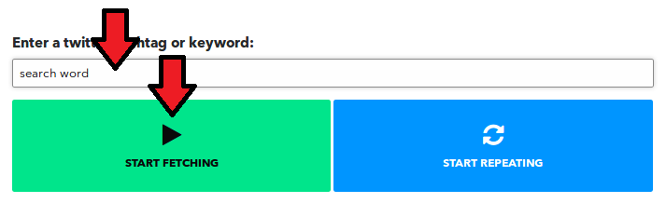

## Toggle autoread

*Note: the auto read disables the repeat button.*You can select the checkbox if it’s enabled it will read a full tweet and then waits until a new one comes in to read it again.

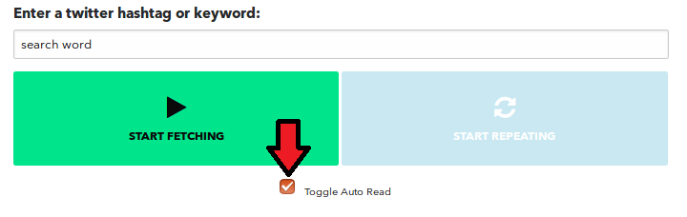

## Repeat your tweets

*Note: when you are repeating your tweets the app will stop fetching new tweets.*When the button is available you can click it and it will start reading your first tweet in the list. After it’s done it will read the second and so on. After the last tweet it will start again with the first one. To stop this you can simply click the button again